**Main factors associated with hiring at UN agencies**

**Analytical Report**

**Prepared By:**

Yousof Hajhasan 20200976

Abdulrahman Melhem 20180568

Zaid Abdullah 20200590

Omar Qandil 20190306

Mohammed Morshid 20200124

Yazeed Khaleel 20200354

**Course Name**: Data Visualisation **Tutor Name:** Dr.Osama Abdelhay

**Table of Contents**

**1. Explanatory and Exploratory Data Analysis Summary**

**1.1 Purpose**

**1.2 Procedures**

**1.3 Outcomes**

**1.4 Conclusion**

**2. Introduction**

**3. Discussion**

**3.1 Visualization**

**3.1.1 The effect of number of fluent languages on acceptance**

**3.1.2 Hiring Percentage from roster by region**

**3.1.3 Hiring Percentage from roster by account status**

**4. Recommendations**

**5. Appendix**

**1.   Explanatory and Exploratory Data Analysis Summary  
  
1.1 Purpose**To investigate and analyze the potential internal and external factors that may have played a role in the acceptance of applicants in the UN and to determine which factors may have had a positive impact on the acceptance process.  
  
**1.2 Procedure**In this study, we selected the recruitment applicants that have been chosen from the roster talent pool, recognizing the limitation of not having access to non-roster data. The provided dataset included a variety of characteristics. We analyzed these attributes and employed visualization techniques such as plotting distributions to identify any potential correlation and determine the factors that influence the acceptance of applicants, and we will discuss these factors at the third part of this report.  
   
**1.3 Outcome**The most relevant factors that showed results of acceptance ratio are: region, where it revealed the acceptance percentages difference for each region; account status, where it demonstrated the relation between being external or internal and being accepted or not; and number of languages, where it indicated how many languages each applicant is fluent in.

**1.4 Conclusion**The most influential factor on applicant acceptance appears to be the number of languages that applicant is fluent at, region, and account status had little to no influence.

**2.Introduction**  
In order to gain a deeper understanding of the acceptance process for applicants at the United Nations, we chose to focus on the recruitment dataset, specifically by analyzing the information of applicants who were selected from the roster pool. Through this method, we aimed to identify potential factors that may have played a role in their acceptance and determine which of these factors may have had the most significant impact. By conducting this analysis, we were able to gain insights into various aspects such as the potential impact of age on recruitment levels and the observation that there are relatively equal acceptance rates among genders, However, these two analyses were not found to have a significant effect on acceptance. Some of the more impactful factors included information about the status of the applicant's account, whether they were internal to the recruitment system or had an external account, as well as the applicant's region, as acceptance percentages varied among different regions. Our approach also revealed that the number of languages that each applicant is fluent in is a significant factor in the acceptance process. All applicants must at least be fluent in English, and the more languages an applicant is fluent in, the higher their chances of being chosen among the other applicants.

**3. Discussion**

**3.1 Visualization**

**3.1.1 The effect of number of fluent languages on acceptance:**

The produced Bar plot (**Figure 3.1.1**) Our analysis revealed that the number of languages fluently spoken by the applicants is a significant factor in the acceptance process. The distribution of the applicant's number of languages and their percentages was evaluated, and it was observed that being fluent in five languages had the highest percentage, which was almost 7 times higher than being fluent in four languages. Additionally, having four languages was found to be almost twice as high as having two or three languages, which both had similar percentages. Being fluent in one language had the lowest percentage among the evaluated languages.

**3.1.2 Hiring Percentage from roster by region:**

The distribution of acceptance percentages among different regions was also evaluated (as shown in **Figure 3.1.2**). It was observed that Africa had the highest hiring percentage, which was 20% higher than Eastern Europe (the second highest). Latin America and the Caribbean had similar acceptance levels, while Asia Pacific and Western Europe had the lowest percentages.

**3.1.3 Hiring Percentage from roster by account status:**

The distribution of acceptance percentages between internal and external applicants was also evaluated (as shown in **Figure 3.1.3**). It was found that internal applicants had 2.5 times higher chances of being hired compared to external applicants.

**4. Recommendation**

Based on the results of our study, we recommend that you place a greater emphasis on the number of languages fluently spoken when assessing your qualifications for the United Nations. Our findings indicate that being fluent in multiple languages is positively correlated with a higher acceptance rate.

Furthermore, it would be beneficial for you to consider taking language classes or language-specific training programs that could help increase your fluency levels and potentially increase your chances of being accepted.

Additionally, you should consider conducting similar studies in the future to monitor the acceptance rate and to identify any new trends or factors that might influence the acceptance process. This will help you stay updated with the latest trends and make informed decisions when it comes to your application for the United Nations.

**5. Appendix**

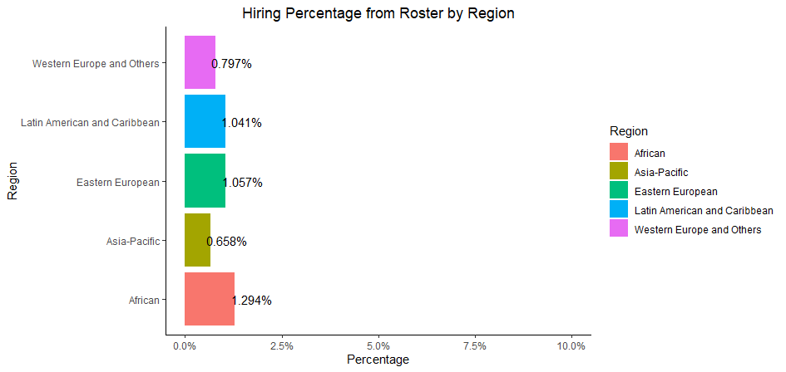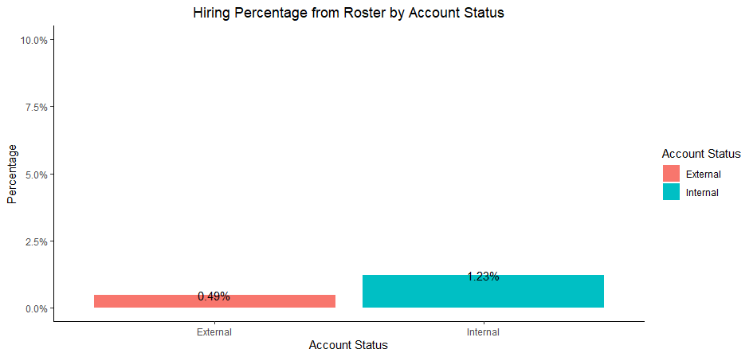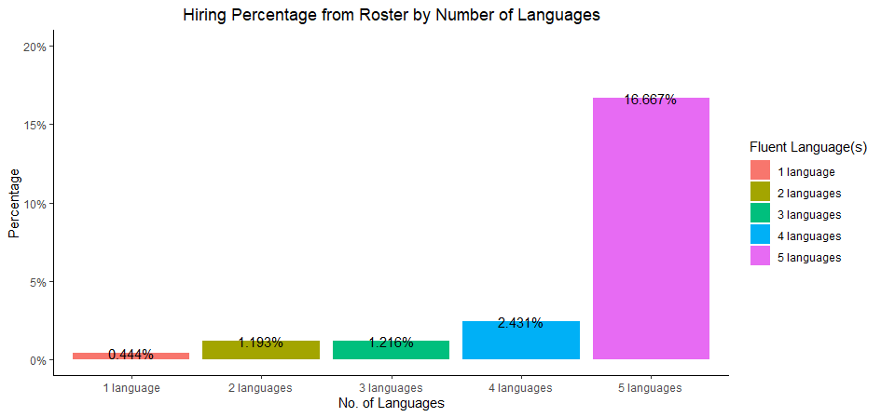**5.1 Figures:**

***Figure 3.1.3***

***Figure 3.1.2***

***Figure 3.1.1***